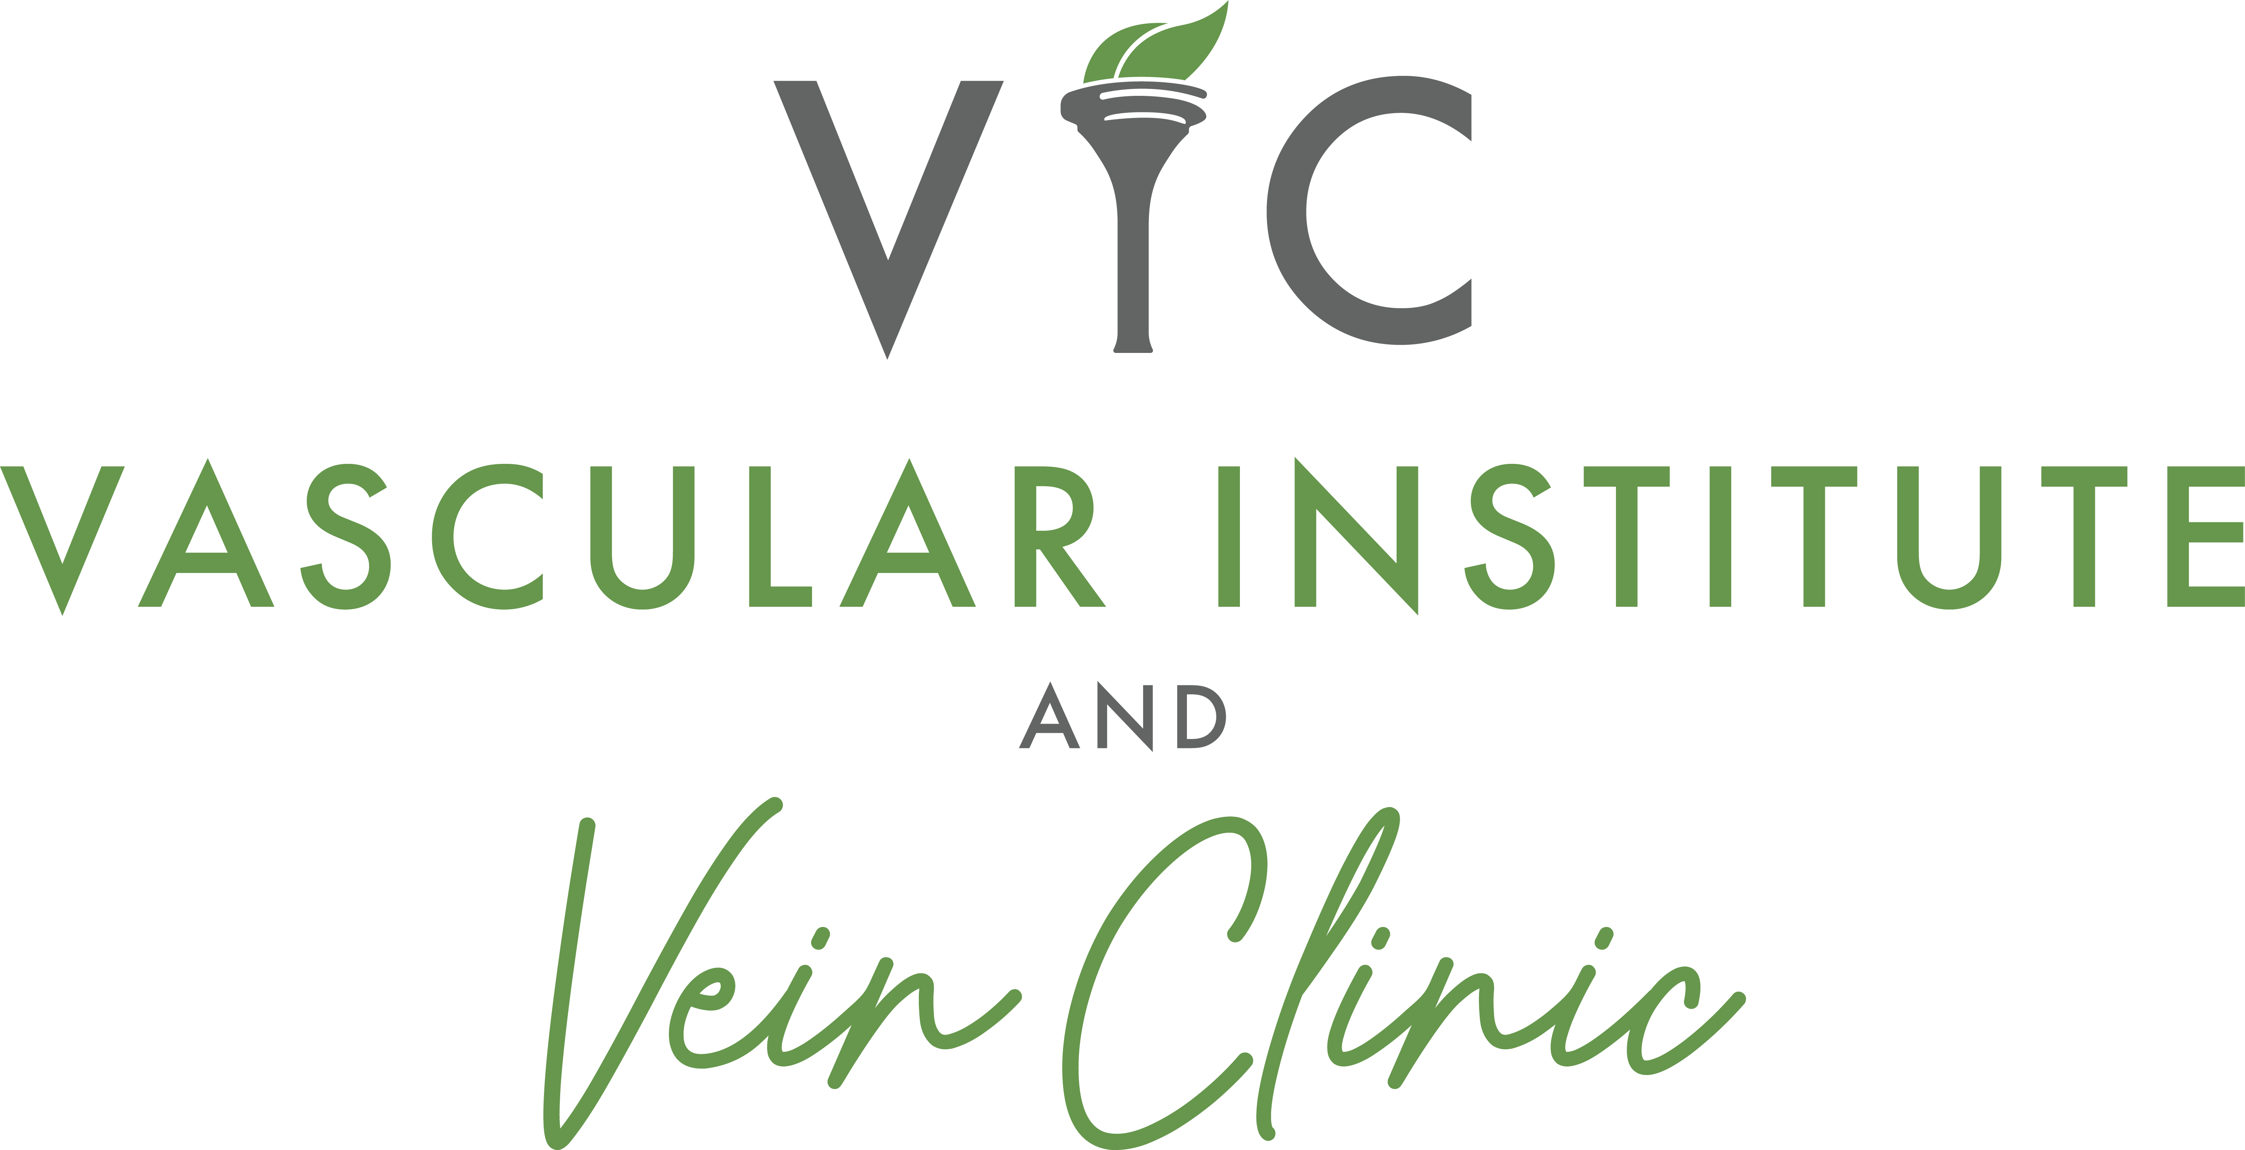

Call for Poster Submissions: 2026 Faces Conference
IMPORTANT: Abstract Review Required
All poster topics and abstracts must be reviewed and approved by the Faces of PAD Review Committee prior to acceptance into the competition. Submission of an abstract does not guarantee acceptance.

Conference Overview
We are excited to invite healthcare professionals, students, researchers, and clinicians to submit abstracts for poster presentations at the 2026 Faces of PAD Conference. Submissions may cover vascular surgery, vascular medicine, vascular ultrasound, wound care, interventional procedures, rare findings, innovative treatments, and impactful clinical cases.

Key Details
- Outstanding Poster Presentation Award: $300
- Abstract Submission Deadline: September 1, 2026
- Acceptance Notification: September 15, 2026
- Final Poster Submission Due: October 15, 2026
- Poster Showcase & Judging: October 23, 2026

Submission & Review Process
To ensure a high-quality educational experience for conference attendees and a fair judging process, all poster topics and abstracts must be reviewed and approved before acceptance into the competition.
- Relevance to vascular medicine, vascular surgery, vascular ultrasound, wound care, or related specialties
- Scientific and clinical merit
- Educational value
- Quality of supporting data and imaging
- Originality and innovation
- Overall organization and clarity
Only approved abstracts will be accepted for poster presentation and judging.

Abstract Submission Requirements
- Title
- Author(s) and Credentials
- Institution/Organization
- Background
- Methods or Case Description
- Results or Findings
- Conclusions
- Clinical Relevance

Preparing Your Poster
Choose a relevant topic, collect supporting data and images, create a clear and visually appealing design, verify image quality, proofread carefully, and practice presenting your findings.

Additional Tips
- Seek feedback from colleagues or mentors before submission.
- Focus on educational value and clinical relevance.
- Arrive early to set up your poster on showcase day.
We look forward to reviewing your submissions and showcasing outstanding work at the 2026 Faces of PAD Conference. Good luck!

